Pokhara University

Level: Bachelor | Semester – Spring | Year : 2006
Programme: BE |  | Full Marks: 100
Course: Signal and System |  | Time : 3hrs.

Candidates are required to give their answers in their own words as far as practicable.
The figures in the margin indicate full marks.

Attempt all the questions.

 | - Define a signal and a system with example. Also write different types of signal with examples.  - Define linearity and causality of a system. For a continuous time system with input x (t) and output y (t) related by y (t) = x (2t), check linearity and time variance of the system. | 7  8
 | - The following figure shows the sawtooth waveform. Find the exponential Fourier series for this waveform. Also plot the magnitude and phase spectrum of the signal.  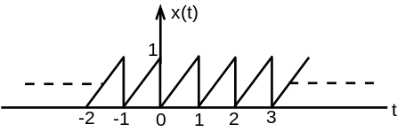  - Find the Fourier Transform of a exponentially damped sinusoid described by 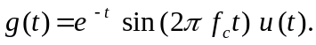 | 8  7
 | - Obtain the fourier transform of a rectangular pulse of duration 2 seconds and having magnitude of 10 volts, starting from origin.  - Prove that, when two signals are multiplied in time domain, then they are transformed into the convolution of their individual Fourier Transform in frequency domain. | 8  7
 | - Compute the 4-point DFT of the sequence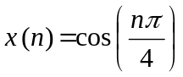.  - Compute the IDFT of the sequence y (k) = [ 1, 2, 3, 4] | 7  8
 | - Define linear time invariant (LTI) system. For an LTI system, prove that 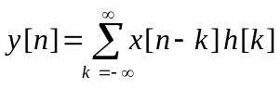 when x [n] is the input to the system with impulse response h [n] and y [n] is the corresponding output.  - Find the output y (t), if a rectangular pulse x (t) is passed through a RC filter shown in the figure below:  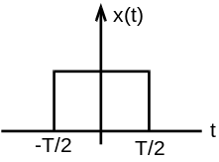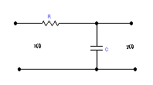  x(t)  y(t) | 8  7
 | - What is distortion? Define a distortion less transmission line. Also explain phase distortion and frequency distortion.  - Obtain the direct form - II realization of LTI system described by difference equation: 2y (n) + y (n –1) – 4y (n-3) = x (n) +3x (n- 5) | 7  8
 | Write short notes on: (Any Two)  - Parseral’s power theorem  - Ideal low pass filter  - Circular convolution | 5×2

